RAJALAKSHMI ENGINEERING COLLEGE
RAJALAKSHMI NAGAR, THANDALAM – 602 105


CS23332
DATABASE MANAGEMENT SYSTEM LAB
Laboratory Observation Note Book

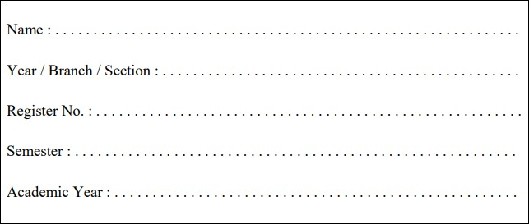
Aathi Kesavan p

2
nd

Year/ AIML / A

2315010
02

3
rd

Semester

2024
-
2025

CS23332 DATABASE MANAGEMENT SYSTEMS

Name | Aathi Kesavan P
Roll No | 231501002
DEPT | AIML
SEC | A
INDEX PAGE

SL.NO |  | DATE |  | NAME OF THE EXPERIMENT |  | PAGE NO | MARK | FACULTY SIGNATURE
01 |  | 24-7-2024 |  | CREATION OF BASE  TABLEAND DML  OPERATIONS
02 |  | 26-07-2024 |  | DATA MANIPULATIONS
03 |  | 30-07-2024 |  | WRITING BASIC SQL SELECTSTATEMENT
04 |  | 02-08-2024 |  | WORKING  WITH  CONSTRAINTS
05 |  | 07-08-2024 |  | CREATING VIEWS
06 |  | 14-08-2024 |  | RESTRICTING AND SORTINGDATA
07 |  | 27-08-2024 |  | USING SET OPERATORS
08 |  | 03-09-2024 |  | WORKING WITH MULTIPLETABLES
09 |  | 10-09-2024 |  | SUB QUERIES
10 |  | 20-09-2024 |  | AGGREGATING  DATAUSING  GROUP FUNCTIONS
11 |  | 24-09-2024 |  | PL SQL PROGRAMS
12 |  | 01-10-2024 |  | WORKING WITH  CURSORPROCEDURES  AND FUNCTIONS
13 |  | 08-10-2024 |  | WORKING WITH TRIGGER
14 |  | 18-10-2024 |  | MONGO DB
15 |  | 25-10-2024 |  | OTHER DATABASE OBJECTS
16 |  | 1-11-2024 |  | CONTROLLING USER ACCESS
 | Ex.No.: 1 |  |  |  | CREATION OF BASE TABLE AND DML OPERATIONS
 | Date: |  | 24/7/24

- Create MY_EMPLOYEE table with the following structure

NAME | NULL? | TYPE
ID | Not null | Number(4)
Last_name |  | Varchar(25)
First_name |  | Varchar(25)
Userid |  | Varchar(25)
Salary |  | Number(9,2)

CREATE TABLE MY_EMPLOYEE (ID NUMBER(4) NOT NULL, Last_name
VARCHAR2(25), First_name VARCHAR2(25), Userid VARCHAR2(25),Salary NUMBER(9,
2));

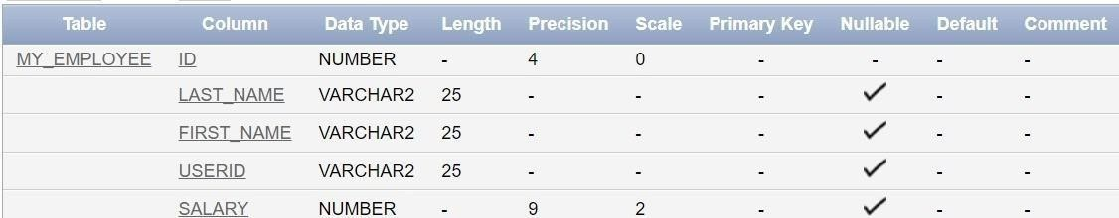
- Add the first and second rows data to MY_EMPLOYEE table from the following sample data.

ID | Last_name | First_name | Userid | salary
1 | Patel | Ralph | rpatel | 895
2 | Dancs | Betty | bdancs | 860
3 | Biri | Ben | bbiri | 1100
4 | Newman | Chad | Cnewman | 750
5 | Ropebur | Audrey | aropebur | 1550

Begin
INSERT INTO MY_EMPLOYEE VALUES (1, 'Patel', 'Ralph', 'rpatel', 895);
INSERT INTO MY_EMPLOYEE VALUES (2, 'Dancs', 'Betty', 'bdancs', 860); End;

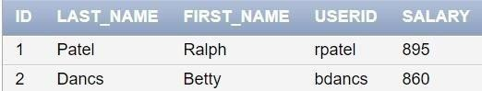

- Display the table with values.

Select * from My_Employee;

- Populate the next two rows of data from the sample data. Concatenate the first letter of the first_name with the first seven characters of the last_name to produce Userid.

Begin
INSERT INTO MY_EMPLOYEE (ID, Last_name, First_name, Userid, Salary)
VALUES (3, 'Biri', 'Ben', SUBSTR('Biri', 1, 1) || SUBSTR('Biri', 1, 7), 1100);
INSERT INTO MY_EMPLOYEE (ID, Last_name, First_name, Userid, Salary)
VALUES (4, 'Newman', 'Chad', SUBSTR('Newman', 1, 1) || SUBSTR('Newman', 1, 7), 750); End;

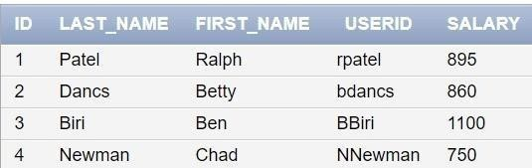

- Delete Betty dancs from MY _EMPLOYEE table.

DELETE FROM MY_EMPLOYEE WHERE Last_name = 'Dancs';

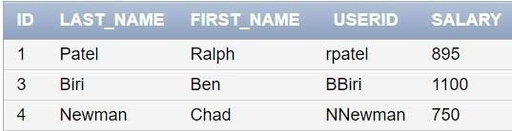

- Empty the fourth row of the emp table.
DELETE FROM MY_EMPLOYEE WHERE ID = 4;

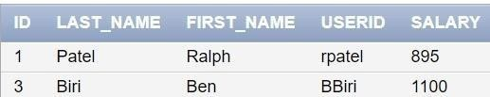
- Make the data additions permanent.

COMMIT;

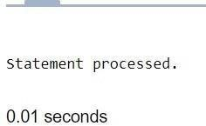
- Change the last name of employee 3 to Drexler.

UPDATE MY_EMPLOYEE SET Last_name = 'Drexler' WHERE ID = 3;

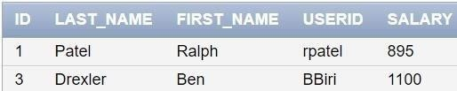

- Change the salary to 1000 for all the employees with a salary less than 900.

UPDATE MY_EMPLOYEE SET Salary = 1000 WHERE Salary < 900;

